Principals
Leo B. Womack – Founder and Chairman
Leo has spent his entire career in Houston. He began his career as a CPA with Arthur Andersen and then purchased a CPA firm in the Texas Medical Center. In the early 80’s this firm was acquired by a large national firm and Leo focused on private investments and entrepreneurial activities. Leo was a co-founder and CFO of Park Plaza Hospital (376 beds) until it was sold to a NYSE Hospital Management Company. Later he was involved as the financial principal in founding one of the first surgery center companies, a long-term care hospital, and numerous other life science companies primarily in medical devices.
He was a founding member of the Houston Angel Network (HAN) and later served as its President and Chairman, and is still an active member. He continues to search for unique opportunities in real estate, early stage technology, medical device, and micro-cap public companies involving these disciplines.
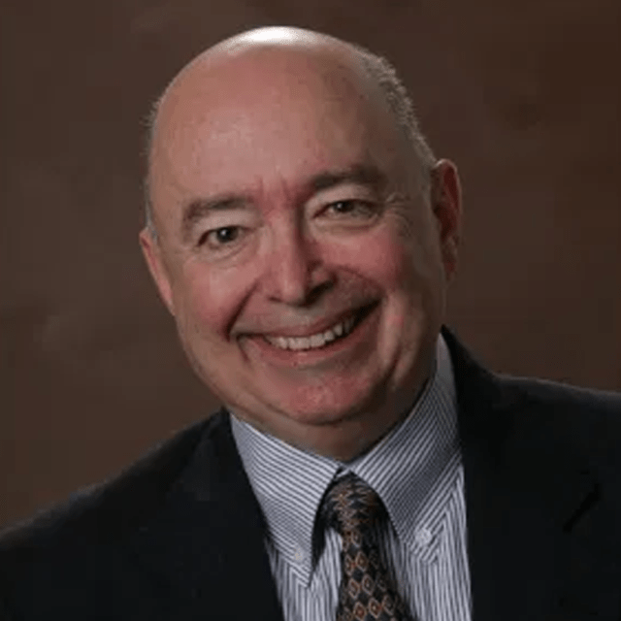

L. Barton Womack – Managing Director

L. Barton Womack is a visionary company builder, board member, CEO, investor, producer, promoter, and inventor with over 30 years of high-stakes success across entertainment, media, and cutting-edge technology. A master of corporate branding, strategic communications, and business development, Bart excels at launching explosive PR and marketing campaigns for bootstrapped startups—turning limited funds into massive impact through street-level grit to global digital dominance. His explosive career includes producing major motion pictures, television shows, interviewing presidential candidates, and owning the state’s largest, most successful nightclub for over five years. He orchestrated blockbuster events and concerts for thousands and engineered campaigns that reached millions, igniting cultural movements and inspiring generations.
A passionate patron of the arts and sciences, Bart produced and hosted a public interest TV show that fueled his drive to secure 501(c)(3) status for Houston Media Source. He then masterminded a powerhouse campaign that delivered a game-changing 10-year, $12 million grant from the City of Houston—plus millions more—ensuring vibrant community media for the long haul. Bart remains deeply committed to impact, volunteering locally and leading media/comms for nonprofits like the Future of Humanity Foundation to advance human resilience and flourishing.
Now, Bart unleashes his futurist fire as Founder, CEO, and Inventor of Eden Grow Systems, a Houston-based NASA spinoff revolutionizing food security. Adapting NASA’s Controlled Ecological Life Support Systems (CELSS)—tech born for deep-space survival—Eden delivers efficient, soil-free, water-saving aeroponic and closed-loop farming. Bart invented The LifePod and advanced Grow Towers: self-contained, climate-controlled aquaponic powerhouses granting food independence to families, communities, urban hubs, remote outposts, and military bases. Featured in NASA Spinoff (“Astronaut Life Support for Earth Families”), Houston Chronicle, Texas Monthly, FOX 26 Houston TV segments, and more, Eden attracts elite investors like SpaceFund and deploys in landmark spots like downtown Houston’s Niels Esperson Building. Bart is forging food sovereignty, shattering supply-chain fragility, and fueling sustainable abundance—bridging legendary cultural impact with frontier tech to empower humanity on Earth and beyond.
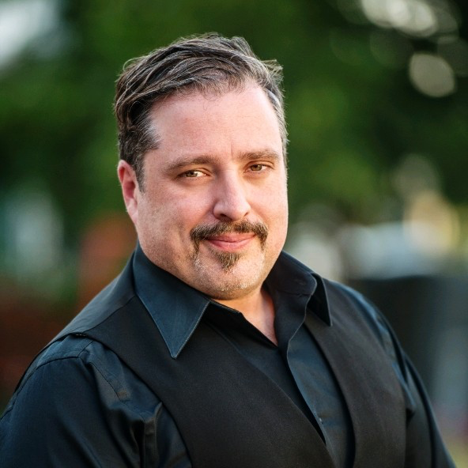

Meagan Crawford – Partner

Meagan is an expert in finance and entrepreneurship, with a specific focus on the most exciting new business sector of our time, space commercialization. She is building the capital stack for the private space industry through investments in and significant contributions to venture capital, private credit, spaceport-adjacent real estate development, and the structuring of new space insurance products. She is a co-founder of SpaceFund where she architected two top-performing venture funds delivering best-in-class returns. Meagan is also a start-up investor, coach, mentor, and advisor. She is a frequent speaker and writer on the development of the space industry.

Meagan was a cofounder of the NewSpace Business Plan Competition, the world’s longest-running space business plan competition that has launched hundreds of startups and catalyzed an entire industry. She is a member of the Board of Directors or a Board Advisor for more than 10 organizations, in the for-profit and non-profit realms. She holds an MBA in Entrepreneurship and Finance from Rice University as well as a BBA in Management, Marketing, and Supply Chain Logistics from the University of Houston. Formerly, she was a Technology Transfer Specialist at NASA, a professor of Executive Communication at the University of Houston, a management consultant in the oil and gas industry, and earned her Series 6 and 63 licenses as a financial advisor.
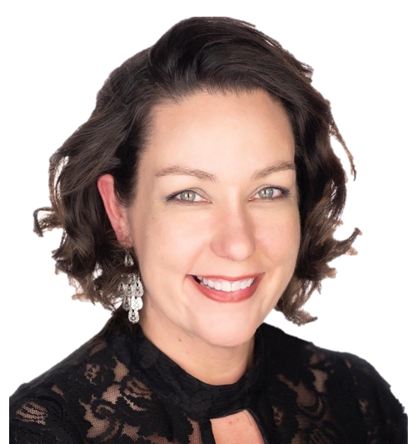

Bryan Talebi – Partner

Bryan is the CEO and Co-Founder of Ahura AI, an artificial intelligence and biometric data platform that accelerates human learning and workforce upskilling by 3–5× compared to traditional methods. Since launching in 2018, Ahura has partnered with leading enterprises including Apple and institutions such as Harvard, delivering personalized, adaptive learning experiences that transform professional development at scale.

Bryan began his career as an Aerospace Engineer at NASA Goddard at age 16. He went on to found and scale multiple technology companies, held executive roles at Zocdoc (where he helped drive the company to unicorn status), and served as VP of Sales at several early-stage AI and machine learning ventures. His operational leadership has repeatedly taken companies from startup to profitability or successful exits, while raising and deploying hundreds of millions in growth capital.
In addition to building Ahura, Bryan runs an AI Venture Studio and has invested in dozens of high-potential companies across AI, space, and longevity sectors. A frequent speaker at the World Economic Forum in Davos and the ITU AI for Good Global Summit, he continues to shape the future of intelligent systems and human performance technology.


Advisors

Over the years RFG has been fortunate to build a collection of highly educated and experienced advisors to assist in developing our projects. Our top advisors include:

Dante Bullara – Financial Analysis Advisor

Dante brings financial analysis and leadership experience, from building startups to running organizations. His strategic planning and execution have been applied in a range of industries from plastics product design and manufacturing to corporate finance and marketing. He is a co-founder of KD Industries, a Kansas City based company focusing on using 3D printing in manufacturing. He also serves as the CFO of the Acutis Marketing Group where he directs all financial activities. He is also actively involved in a nonprofit research project building luminescent solar concentrators that may one day revolutionize the way electricity is collected. He is currently a university student pursuing degrees in Computer science and Finance.
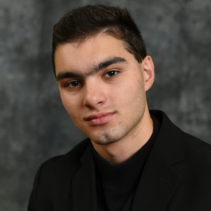

C. Richard Piazza – Life Sciences Advisor

Richard marks 35 years of international experience in medical devices, pharmaceuticals, biotech, and healthcare services ranging from start-ups to large multi-nationals. As CEO for AMEX, NASDAQ & TSX companies, he raised $150 million in private and public equity to fund development projects, product introductions, corporate restructurings, and turnarounds for major institutional investors that included JP Morgan Capital. Richard has significant drug, biologic and device development & clinical trial expertise. He was responsible for contracting domestic and international clinical trial sites, tracking those trials, and gaining regulatory approvals for Class I, II & III medical devices, BLA, NDA & ANDAs. His multiple degrees earned from State University of New York, include a BS in Economics, BS in Speech Pathology and PhD studies in Economics. Richard has served as an advisor to MD Anderson Cancer Center Department of Technology Transfer, and as guest lecturer at Caltech, MIT, USC, and Rice University Jones School of Management. He was a partner with La Jolla Capital Partners before relocating to Houston where he continues to work with early stage Life Science companies as an Advisory Board member of BioHouston.
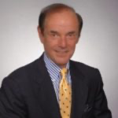

Bruce Badeau – Financial Analysis Advisor

Bruce founded First Sovereign Equity Research in 1996, which performs financial modeling, valuations and business planning services for companies seeking to raise capital, or prepare for acquisitions. Bruce is proficient in Excel VBA programming, developed V-Rents©, a business planning software application for Volvo Construction Equipment Rents, and designed and programmed dozens of other financial applications, including a deal making mobile web app: www.sharkcaptable.com. He has structured 80 companies using VentureCAD©, a financial forecasting tool for structuring deals in oil and gas exploration, biotech, pharmaceutical, mobile web apps, robotics, consumer products, autonomous drones, deep-sea drilling equipment, space exploration, and commercial construction. Bruce is a graduate of The Lawrenceville School, earned a B.A. in Economics, University of California Santa Barbara specializing in corporate finance and securities, and completed Bioengineering Management 633 taught by Jack Gill, through the Rice Alliance, at Rice University.
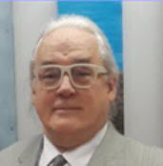

Andrew Nat – Business Development Advisor

Andrew is passionate about growing and restructuring businesses and innovation. He has over 30 years of global business experience in the Life Science, Information Technology, and Energy sectors, including expertise in Technology Commercialization, the Capital Markets, Corporate Development, Strategic Planning, M&A, Project Finance, Board Membership, and Deal Execution. During his career, he has closed over $2.6 billion in transactions. Andrew grew Assets Under Management (AUM) 700% for an investment subsidiary and closed $490 million in asset-based investments in the marine, Telcom, aviation and manufacturing industries. He closed more than $66 million in life science technology deals resulting in 8 publicly traded companies and 2 acquisitions. Currently, Andrew serves as the Managing Partner for ThirdWave Partners, LLC, a consulting firm he founded that focuses on corporate development, technology commercialization, capital raising, and financial and project structuring. He assists private equity firms in evaluating portfolio companies; advises early stage companies on strategy, business development, and fundraising; and acts as an Investment Committee Advisor to a regional seed round fund and an economic development corporation. He also served as a Board Member and Advisor for corporate, non-profit, and government entities. Andrew earned his MBA from Yale University and his Bachelor of Arts from Columbia University.

